**Week 4**

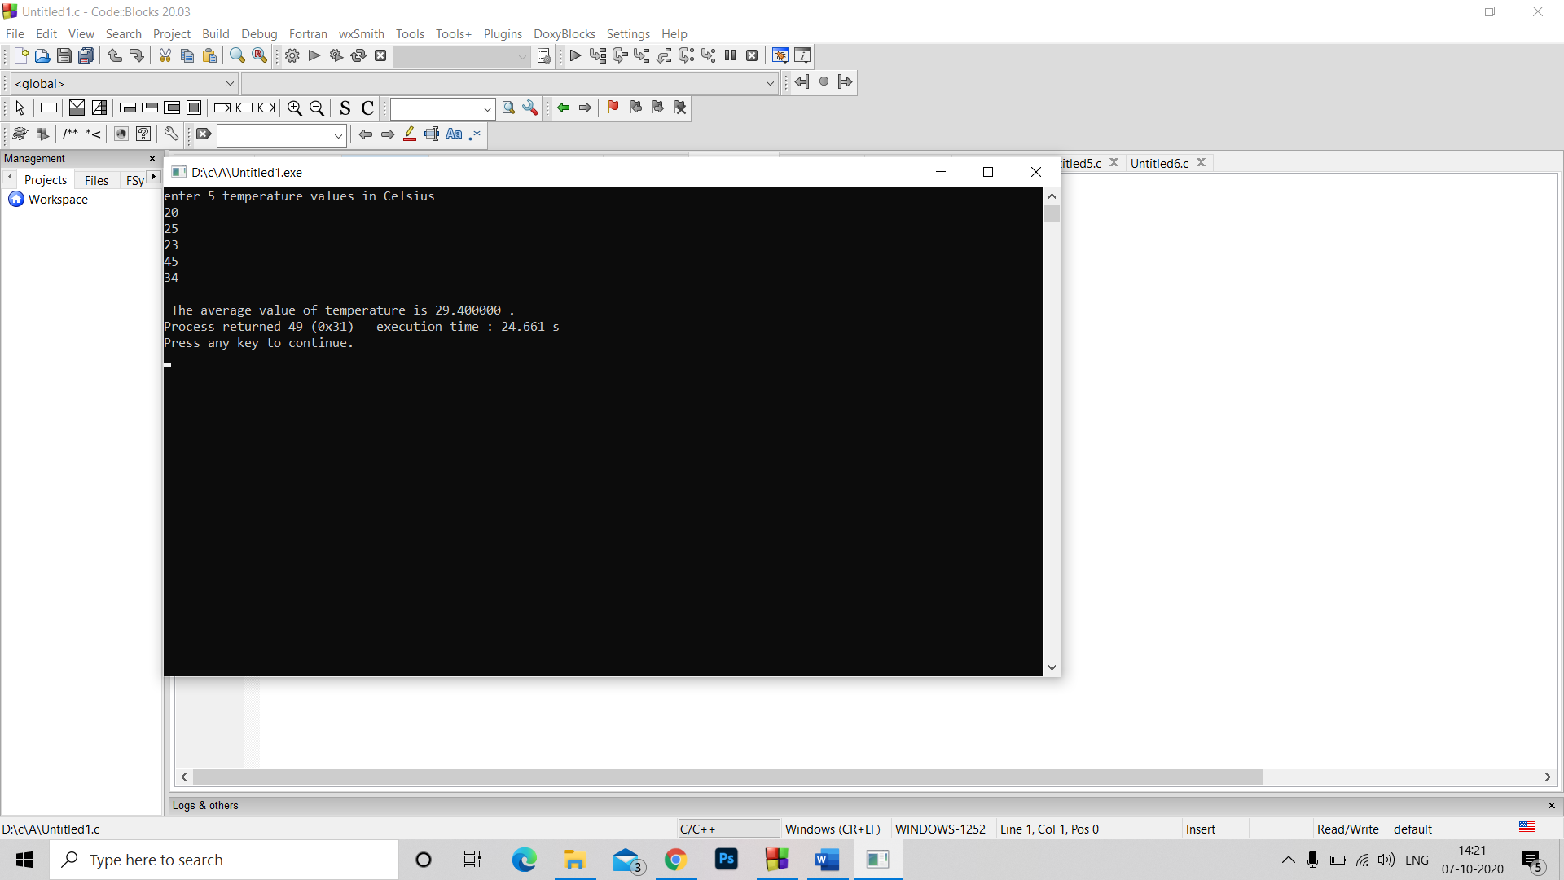Q1. #include<stdio.h>

#include<stdlib.h>

void main()

{float a,b,c,d,e;

float avg;

printf("enter 5 temperature values in Celsius");

scanf("%f %f %f %f %f",&a,&b,&c,&d,&e);

avg=(a+b+c+d+e)/5;

printf("\n The average value of temperature is %f .",avg);

}

Q2. #include<stdio.h>

#include<stdlib.h>

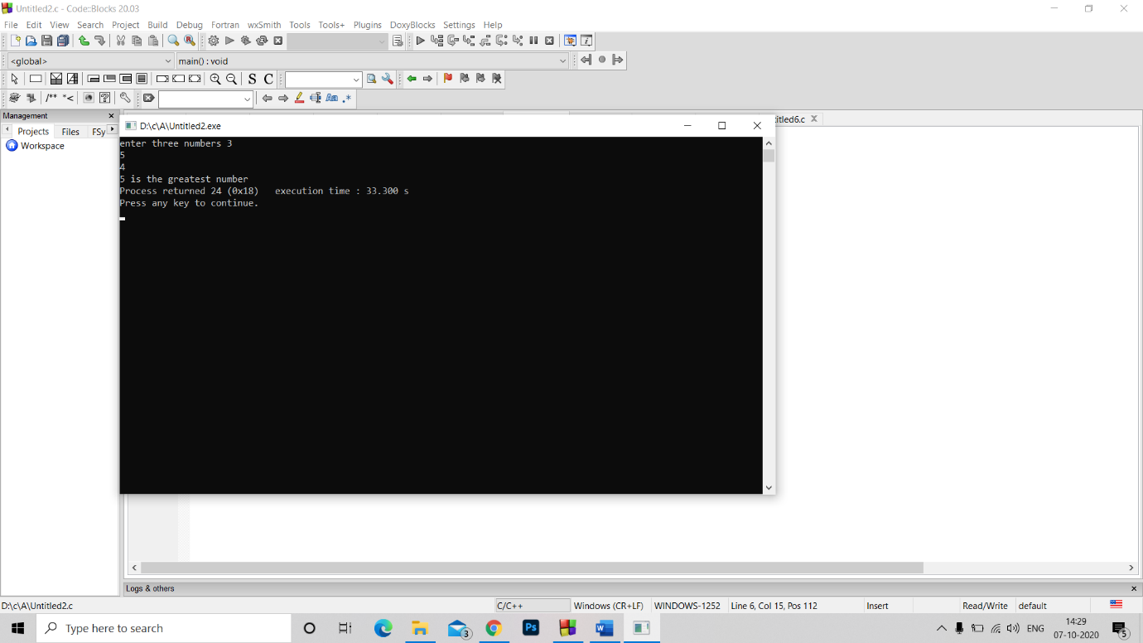void main()

{int a,b,c;

printf("enter three numbers ");

scanf("%d%d%d",&a,&b,&c);

if(a>b)

{if(c>a)

printf("%d is the greatest number",c);

else

printf("%d is the greatest number",a);

}

else if(b>c)

printf("%d is the greatest number",b);

else printf("%d is the greatest number",c);

}

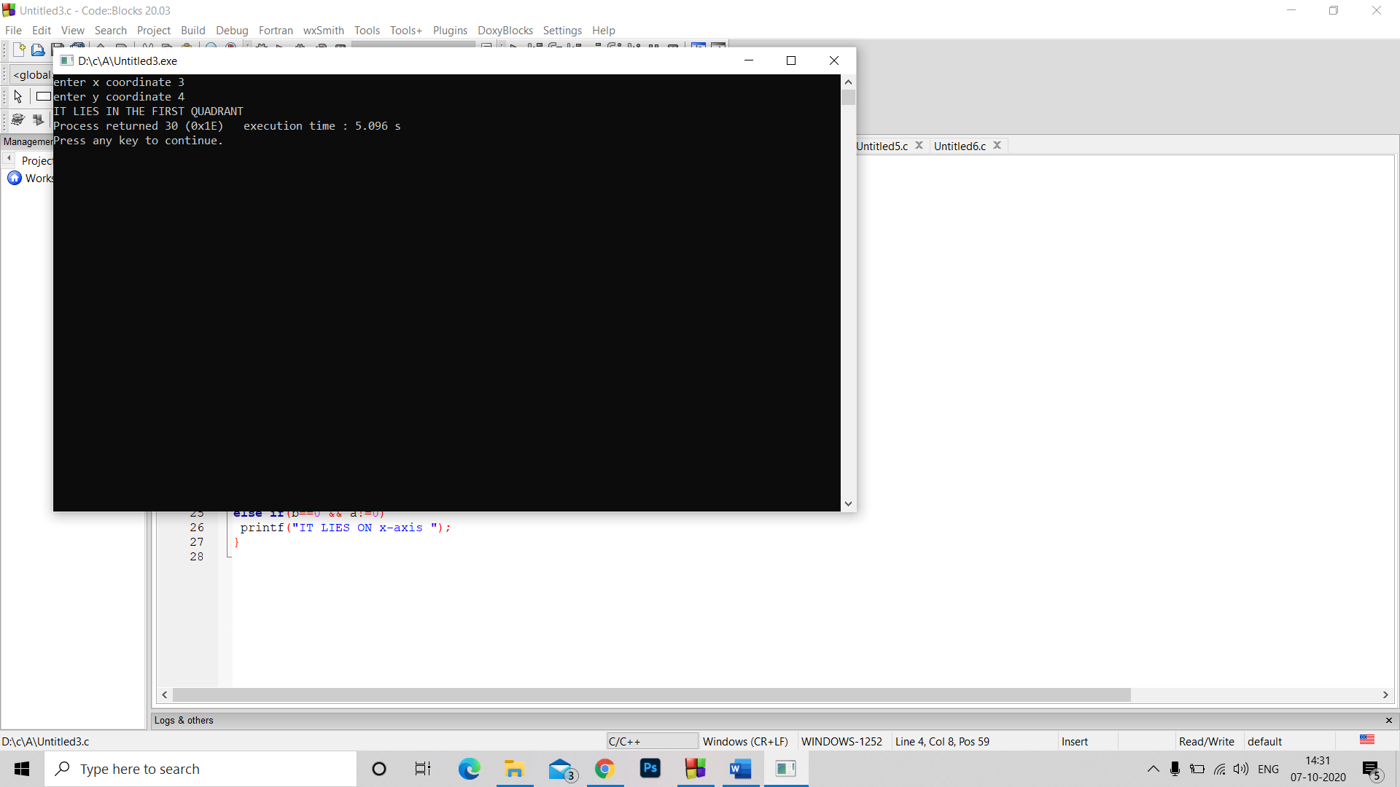Q3. #include<stdio.h>

#include<stdlib.h>

void main()

{int a,b;

printf("enter x coordinate ");

scanf("%d",&a);

printf("enter y coordinate ");

scanf("%d",&b);

//comparision

if(a>0 && b>0)

printf("IT LIES IN THE FIRST QUADRANT ");

else if (a>0 && b<0)

printf("IT LIES IN THE FOURTH QUADRANT ");

else if (a<0&& b>0)

printf("IT LIES IN THE SECOND QUADRANT ");

else if (a<0 && b<0)

printf("IT LIES IN THE THIRD QUADRANT");

else if(a==0 && b==0)

printf("THIS IS ORIGIN");

else if(a==0 && b!=0)

printf("IT LIES ON y-axis ");

else if(b==0 && a!=0)

printf("IT LIES ON x-axis ");

}

Q4. #include<stdio.h>

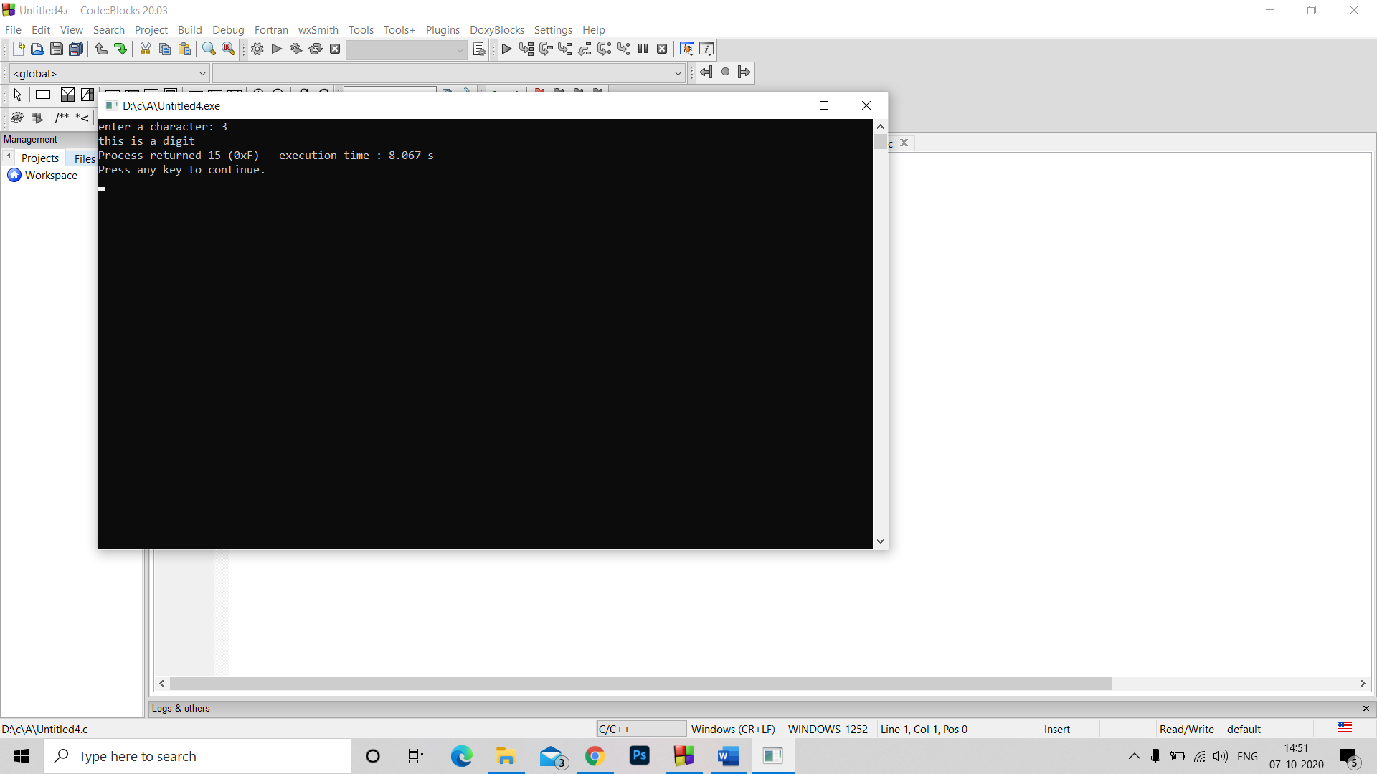#include<stdlib.h>

void main()

{char a;

printf("enter a character: ");

scanf("%c",&a);

if(a>='a' && a<='z' || a>='A' && a<='Z')

printf("this is an alphabet");

else if (a>='0' && a<='9')

printf("this is a digit");

else

printf("this is a special character");

}

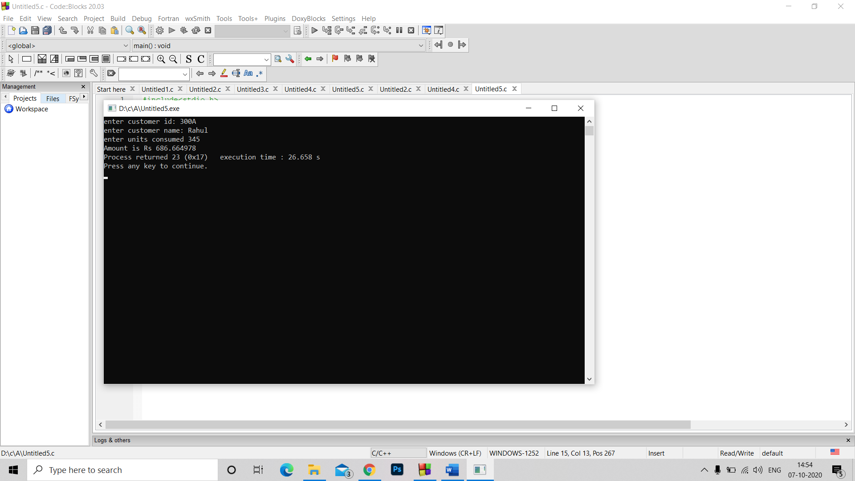Q5. #include<stdio.h>

#include<stdlib.h>

void main()

{char a[20],b[10];

int c;

float A;

printf("enter customer id: ");

scanf("%s",&a);

printf("enter customer name: ");

scanf("%s",&b);

printf("enter units consumed ");

scanf("%d",&c);

if(c<=199)

A= 1.9*c;

else if(c>=200 && c<400)

A=(c-199)*1.5+199*1.9;

else if(c>=400 && c<600)

A=199*1.5+ 199*1.9+(c-399)*1.8;

else if(c>=600 )

A=199*1.5+199*1.9+199*1.8+(c-599)*2 ;

if(A<100)

A=100;

if(A>400)

A=A+0.15*A;

printf("Amount is Rs %f",A);

}